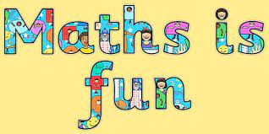
Name__________________________________
Maths Home learning task- Friday 22nd March 2024

Draw the tens and ones to help you to compare the numbers
23 27
Tens | Ones
Tens | Ones

____________ is the greater number
36 26
Tens | Ones
Tens | Ones

_____________ is the smaller number
Tens | Ones
Tens | Ones
34 27

___________ is the greater number

Re-write the numbers in order starting with the smallest
31 12 26 ________________________________

47 11 29 _________________________________

16 33 27 ________________________________

25 41 14 _________________________________

