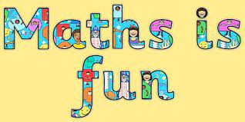

Maths Home learning task- Friday 8th March 2024

We have started work with numbers to 50. The following activities will help children to become familiar and fluent working with these numbers.

- Count 0-50 , pay particular attention to crossing the next 10. E.g. 29 – 30 and 39 - 40 etc. Repeat counting backwards

- ‘What is 1 more than 35?’ Children should know 1 more is the next number (when counting forwards). Repeat for 1 less (counting backwards 1)

- Ask children to say the number you write. E.g., write the number 37. Can children correctly name the numeral?

- Ask your child to write a given number (within 10-50). Are numbers in the correct position? (e.g. forty-seven is written as 47 and not 74). Ensure individual numerals are not reversed.

- https://www.topmarks.co.uk/ordering-and-sequencing/caterpillar-ordering is a great site for ordering and sequencing. Choose numbers to 100 but support children where numbers exceed 50 (sadly, there is no option to work within 50, but it is still a great activity).

- https://www.ictgames.com/mobilePage/countingCaterpillar/index.html set boundaries between 0 and 50.

10
3
4
8
13
12

