Maths Home learning task – Finding half and quarter of amounts. 31.3.23

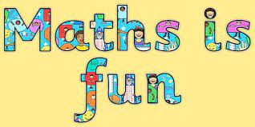
Name ______________________________

Find half (2 equal parts) or quarter (4 equal parts) for each amount.
Use real objects to help you (counters, dried pasta etc.)

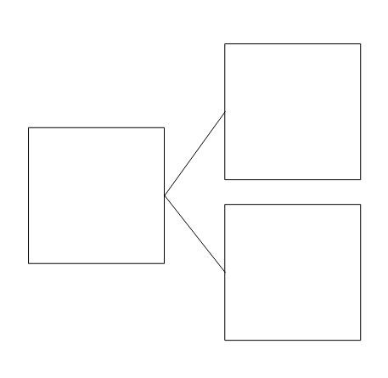
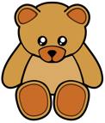

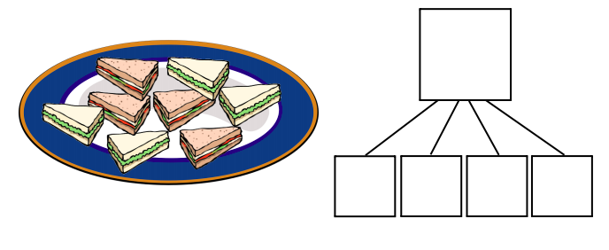

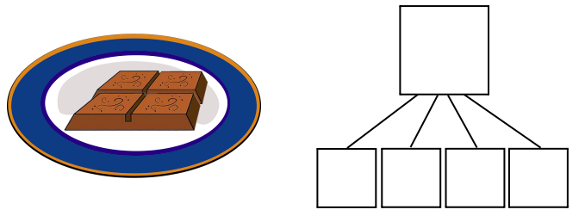

What is half of 4?

What is a quarter of 12?

Stretch it!
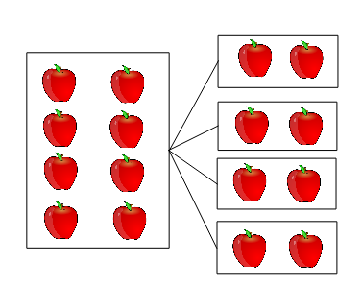
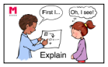

How do you know the apples have been divided into quarters?

